UNION CONNECTIVITY REVIEW call for evidence submission on behalf of:
Newcastleton & District Community Council (NDCC), Newcastleton & District Community Trust (NDCT) and Newcastleton Business Forum (NBF)
Dec 2020
Who we are and where we live:
Newcastleton’s community and businesses are pleased to respond to the UK Gov request for evidence regarding the connectivity review. This paper summarises the collective views of the Community Council representing the wider community perspective of Newcastleton, the Business Forum a membership of 45 tourism and hospitality businesses and Newcastleton & District Community Trust, our community anchor organisation with a membership of 315, over 50% of the adult population in the catchment.
Newcastleton is a rural remote community circa 25 miles off the beaten track. We commonly refer to ourselves as a landlocked island, cut off by extreme weather and flood. A population of 920, 763 living in the heart of the village with a further 160 spread across the hinterland. Located 25 miles north of Carlisle, and 25 miles south of Hawick in the Scottish Borders.
Due to rurality our employment is dominated by the self-employed (approx. 30% v Scotland’s 11%) and dependent on tourism, which is growing in appeal; off the beaten track, a get away from it experience. We have a primary school, surgery, 2 hotels with restaurants/bars, 2 cafes as well as a pub. A Spar, CostCutter, hardware, garage, unmanned community owned fuel pumps, PO counter and a bank that is still operating 2 days pr week. Residents must travel to Hawick to seek health or medical appointments (dentist, chiro, etc). Students must travel to Hawick or Jedburgh for high school, further education at Galashiels takes 3 hours to reach via 2 buses.
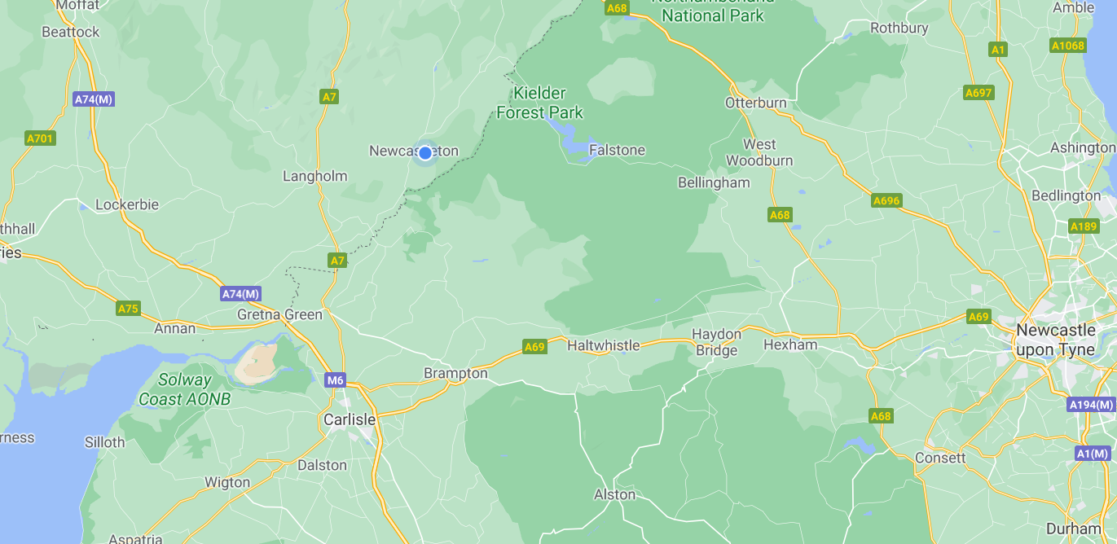

Assessing the need for cross-border connectivity
1. If you represent a place, what is your current strategy for growing the economy and improving the quality of life there? Please provide a summary, but you are welcome to append or link to published strategies.
a) What is necessary to achieve this strategy and what evidence do you have that improved connectivity is needed in this instance?
We expect that transport is not the only factor necessary to achieve regional strategies and would like to understand what else might need to be in place to see benefits from improvements in connectivity.
RE-CONNECTING NEWCASTLETON
Newcastleton’s decline can be traced back to the Beeching railway closures of 1969. What followed has been a slow sustained decline in our dis-connection:
- loss of employment (jobs lost in railway at first followed by timber, transport & manufacturing)
- start of depopulation (now we number 763, losing 30% of our population over last 50 years)
- education failing secondary pupils (length of day; extra time travelling via bus 2hrs/day v rail taking 40mins having a debilitating effect on children after 5 years of doing it daily)
- costs of travel for work; car ownership a necessity/increase in 2+ cars per HH impacting HH income
- loss of a major manufacturer (Barbour clothing incentivised by development to relocate)
The knock-on effects still reverberate:
- increase in stay-at-home mums not able to seek work
- failing our children - lack of opportunity/participation in after-school activities crucial to a young person’s social development; leading to lack of confidence and increasing level of mental health problems, particularly amongst our young people.
- Attainment levels are dropping - many leaving school at 16 not seeking further education, those that do, never return.
- increase in antisocial behaviours caused by frustration and lack of prospects - drugs are beginning to penetrate our small community; rural isolation, no regular police presence is allowing the county line drug processes to become established.
The only growth sector is our elderly population; currently 31% forecast to rise to 43% by 2045 increasing strain on local health services.
We face a 90mile round trip to hospital with no public transport available to make an appointment or visit a hospitalised relative – except on a Saturday when you can spend 90 mins visiting before catching the return bus which takes 2 hours. Attending a hospital appointment usually means a full day impacting on those in employment and those with dependants (children/elderly), everyone relying on car owners to get them there. The hospital collection service, (if you qualify), leaves the village at 7am returning at 7pm making it impossible for the vulnerable to use – all users are expected to ‘wait’ till last appointments before departing. This is unacceptable; expecting the most vulnerable to be left sitting, waiting all day, many, are unable to take food/drink with them needing both hands to support themselves and unable to pay to have carer support for full day.
The voluntary community run car scheme for the over 60’s was created following Beeching’s cuts. It provides transport to medical appointments but will be unsustainable in the long term as more of us become dependent on its service. Community transport schemes carry huge liabilities; without qualified support managing statutory checks/maintenance the village cannot operate a scheme without ongoing subsidy.
Bus services are cut to the bone, it is impossible to have a social life or meet friends outside the village - there is no transport out after 2pm. The direct bus service from Hawick-Carlisle on Saturday was cut, replaced with a ‘connecting’ service requiring us to get on from Canonbie but the capacity of the new service is stretched with no guarantee that you can get on it when it meets the Canonbie service; the previous direct service used to accommodate limited mobility users – usage prior to the cut saw 43 journeys by disabled users recorded on a Sat during Q1 2018, by Q2 after the cuts only 3 were recorded. Those with limited mobility are now effectively confined to the village. Our volunteer drivers cannot accommodate wheelchair users, lack of local training and support further restricts their social engagement opportunities.
We want an end social inequality. No price can be put on our children’s education or chances in life. No price can be put on providing facilities so that loved ones can see each other during their declining years. No price can be put on accessing health support services if they are needed.
We can end this by ‘re-connecting Newcastleton’ to the rest of Scotland and England by rail. Reinstating rail will not just eliminate social inequality, it will make up for the lack of investment by the public sector in our community over the past 35 years; not one new job has been created by inward investment from the public purse in that time. However, Newcastleton has made great strides over the past 20 years creating local wealth, developing new sustainable income from tourism, and creating new jobs.
We need much more support to overcome the major barrier to attract inward investment; re-connecting Newcastleton to the rail network will drive this forward, to do this we created
OUR PLACE PLAN: https://www.visitnewcastleton.com/community/holm-hill-buyout/
Newcastleton offers great potential; we want to choose our own destiny and as a community now own the land we stand on; we believe that through owning land we can deliver an inclusive growth strategy utilising tourism and renewables to drive inward investment. Creating a carbon neutral community utilising solar and battery storage providing energy, in turn using this resource to attract inward investment.
Our plan provides space to create a new business park to attract new sectors that can exploit our natural capital; carbon off-set, forestry; research, manufacturing & timber processing.
Land to re-adopt traditional farming methods prevalent before farm subsidy became the norm.
Land – outside the flood plain - to create new modern housing to retain our population and grow it, housing designed to attract affluent commuters from the south once the R100 roll-out is complete even those from the wider North, envious of our land and our house prices, but not our ‘disconnection’.
Inward investment will come if we are better connected enabling us to exploit what we have. Connectivity in every sense will allow us to eradicate the deprivation we have suffered since 1969.
Newcastleton is located at the centre of Borderlands region, looking north (Hawick) east (Langholm) south (Carlisle) and west (Cumbrian & Northumberland). Nowhere is better placed to take advantage of the opportunity Borderlands and the new South of Scotland Enterprise agency presents us.
Newcastleton must be re-connected to be able to play our part in the rejuvenation of southern Scotland.
3. In general terms, is there a need for new or improved transport links between the nations of the United Kingdom? If so, please: explain why and provide evidence to support your view, ensure that your response relates specifically to multi-nation transport links and not to improvements in connectivity in general.
Yes, not just passenger usage but Freight. The flow of timber transport through rural fragile road networks is costing the public purse; the sector forecasts perpetual growth with continued increasing demand for product/supply. The impact of this increased usage and weights on our road network cannot be sustained; our community has suffered road closures for 12 out of the last 60 months (20%) forced on us as a result of dramatic and rapid climate change; increasing flood events (rain and water run-off) as well as snow melts; local authority cutbacks reducing maintenance of roads, gulley’s, and drains. The impact of this pounding on our roads has resulted on lost trade and businesses with the resultant knock-on effect to local employment.
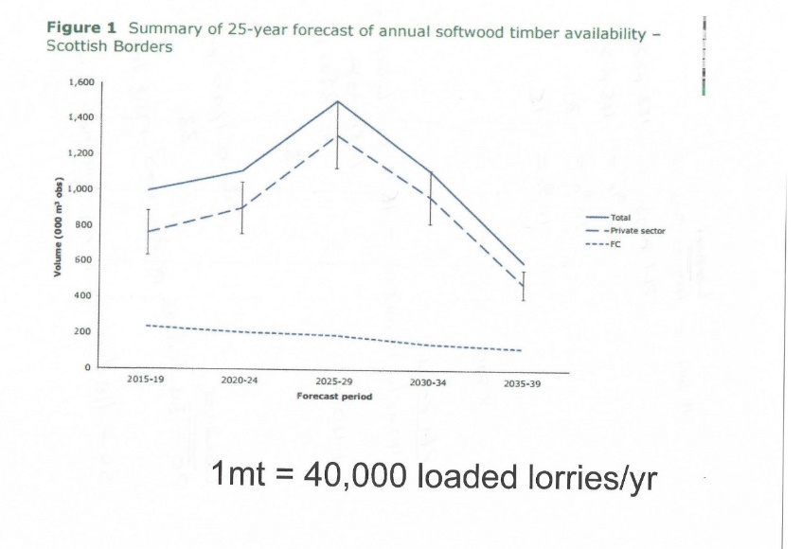
One element not dramatically impacted by climate change is the old rail track bed of the Waverley Line (Edinburgh- Carlisle route), however, land slips on the A7 and A68 connecting the centre of Scotland to England now frequently close key transport routes for long periods. Reopening and utilising the old track bed for passenger traffic, freeing capacity for increased freight will solve a number of cross border challenges.
England and Wales host the largest timber processing and manufacturing capacity with planned increases in investment to match the growth predicted. They need an increasing and regulated supply of timber to deliver the return on investment required to sustain increased employment and the wider supply chain that this sector brings. Switching usage from road to rail, adding a whole new freight sector to this mode of transport enables improved passenger capacity and frequency – even under Covid passenger trains are strained on the East and West coast main lines.
That is besides the gain in reduction in emissions from road freight as well as the modal switch from road to rail of passenger traffic.
4. What are the main obstacles and challenges in improving transport connectivity between the nations of the UK? Please provide evidence relating to any specific challenges that prevent or hinder the development of additional or improved transport links. Please consider socio-economic, political, organisational, and practical issues.
Capital investment and working collaboratively instead of combatively; political point scoring and short-term investment strategies. These barriers have combined to frustrate any sensible dialogue to solve cross border infrastructure investment which now cannot be avoided by either the UK Gov or the Scottish Gov.
Both need to put political differences aside and look at the bigger gains; a proactive flow of traffic; passenger, freight, visitors (both international and domestic) as well as commuters and school children reviewed against the resultant gains in emissions and behavioural changes in modal use as well as the massive social gain amongst the wider communities who live and work in the north of England and south of Scotland. Stopping flow due to poor infrastructure impacts both economies but has a direct and immediate impact on those who live within the borders proximity. Small Scottish communities are suffering just as badly as small English communities. We are all dependent on each other locally to survive but we should not just be surviving, we should be living.
12. Do you have any further comments?
Your introductory remarks refer to the Union as being the most successful partnership of nations in history, you claim connectivity drives economy, jobs, housing, and social cohesion, essential in ensuring that everyone feels the benefits of being part of this union.
We would also like to benefit from this ‘connectivity’, but since 1969 have been left on our own to determine our future. Since that time Newcastleton has stood up for itself, invested in itself and as a community we intend to continue to do that, but we have the potential to be so much more with help and support of the public sector; this can only fully be realised if BOTH the UK and Scot Gov’s work collaboratively to reduce the barriers that connect us.
Reinstating the cross-border rail link extending the soon to be electrified Borders Railway to Carlisle will reignite the investment strategy for the north of England and the south of Scotland.
But it will do more.
- support both the combined Gov’s in their ambitions to reduce emissions from transport
- provide social access to communities who have for too long lived cut off used to accepting their lot rather than being able to compete at the same level as others
- enable simple things like visiting a relative in hospital
- or getting to school in 20 minutes and staying for after school clubs so mum & dad can work for longer

These are priceless and cannot be measured in monetary terms or stats and facts. They are not political, nor radical, just needs that everyone has and most take for granted. Where we live nothing can be taken for granted and it is about time that both the Governments looked at the bigger picture and invested in the people and places that make up the cross-border communities of the UK.

You need to fulfil your promise of levelling up by addressing the causes of regional inequality across the UK. We accept they are complex and historic, requiring long-term, well thought out policy decisions to resolve and the external economic impacts such as COVID-19 and Brexit make this even more complex, but we cannot stand still, northern England and southern Scotland have been left behind, it is our turn to catch up.
Transport is the most effective enabler of an effective growth strategy. The ability to move people and goods across the country is vital to the success of business, the growth of regional economies, and access for people to jobs, housing, education and health services, so good transport connections are needed to ensure that regions across the UK are able to maximise their potential, your words not ours. We wholeheartedly agree but for our place plan to work we need you to deliver.

Barbara Elborn BEM, on behalf of the community and business of Newcastleton, Dec 2020

