AGENDA

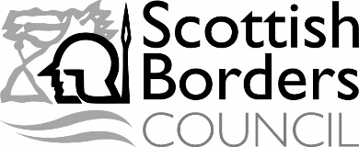 |  | NEWCASTLETON  COMMUNITY COUNCIL
A MEETING of the NEWCASTLETON COMMUNITY COUNCIL will be held at 7pm on Tuesday 9th August in the Newcastleton Village Hall.

BUSINESS

1. | Welcome and Introduction. Welcome and introductions by Councillor Watson McAteer (Returning Officer).
2. | Apologies for Absence.
3. | Order of Business.
4. | Declaration of Interests
5. | Membership of Community Council  Note new membership of Community Council.
6. | Appointment of Chairman  Nominations to be invited by Councillor McAteer
7. | Appointment of Vice – Chairman  Nominations to be invited by the Chairman.
8. | Appointment of Secretary  Nominations to be invited by the Chairman.
9. | Appointment of Treasurer  Nominations to be invited by the Chairman.
10. | Any Other Items which the Chairman Decides are Urgent.
11. | Date of Next Meeting.
Membership of Community Council :- Keith Brough, James Lewis, Lyndsay Patterson, Marcus Day, Iain Crosbie, Barbara Elborn, Robert Irwin and Ian Nichol

Please direct any enquiries to Watson McAteer
Tel : 07429557887, Email: watson.mcateer@scotborders.gov.uk

